Please Post on Union Board This Notice Posted January 13, 2026

CUPE NATIONAL UNION EDUCATION ONTARIO SPRING WEEKLONG SCHOOL 2026

(Formerly known as Dave Saunders Memorial School)

April 26 - May 1, 2026
White Oaks in Niagara-on-the -Lake
WORKSHOPS – MUST SELECT ONE COURSE ONLY

WSIB Bundle
  - WSIB LEVEL I – Rights and Obligations
  - WSIB Level II – Benefits and Services

Health and Safety Bundle
  - Staying Alive While Earning a Living
  - Violence in the Workplace
  - The Body in the Workplace
  - Toxic Substances
  - Principles of Control
  - It’s the Law
  - Workplace Representation
  - The Myth of Worker Carelessness
  - Making Work Fit the Worker
  - Worker Representatives

Navigating Interpersonal & Group Conflict
  - Conflict is a part of our lives – at work, in the union, and at home. In this workshop
we’ll build our conflict skills by looking at: • How our beliefs about conflict and our
conflict style affect what happens in a conflict. • Sources of conflict in the union and at work. • Conflict dynamics, cultural differences and power • Choosing the best response in a conflict. • Conflict communication skills and difficult conversations

- Steward Learning Series Bundle (Prerequisite Intro to Stewarding)
  - Grievance Handling
  - Duty of Fair Representation
  - Challenging racism in the workplace
  - Mediating member-to-member conflict
  - Understanding mental health
  - Creating harassment-free workplaces
  - Popular economics for stewards
  - Growing our mobilizing power
  - Literacy Awareness
These workshops are bundle courses. You will be attending all components.

To register, please submit the CUPE Local 5167 Education Request form to the union office by emailing office@cupe5167.org no later than Monday, January 26, 2026 at 4:00pm. For all educational inquiries, please contact Virginia Stonehouse, Education Coordinator, at education@cupe5167.org.

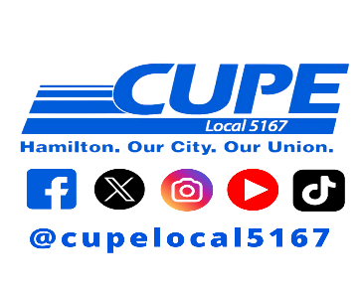

President: Jason Lucas
Vice President: Deann Smith
Executive Administrator: Jodi Coville
Treasurer: Steve Rothwell
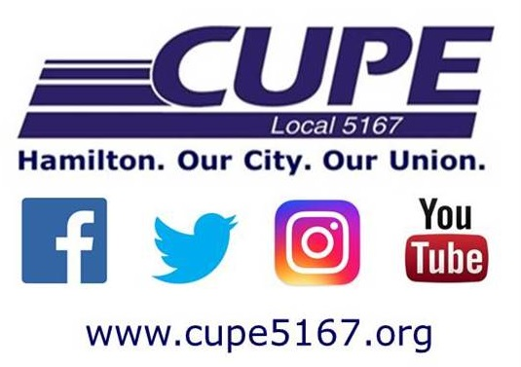
886 Barton Street East
Hamilton, ON L8L 3B7
Phone: 905-522-0917 Fax: 905-522-4011
E-Mail: office@cupe5167.org
COPE: 343; JC:ld

