ELECTION RESULTS

Joint Health & Safety Committee
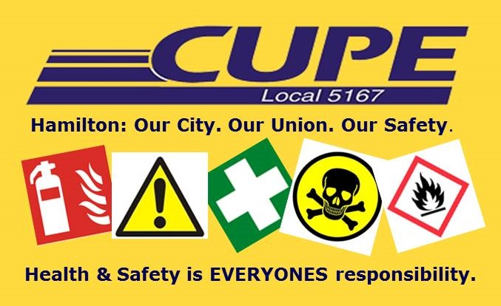

DEPARTMENT/DIVISION

SUCCESSFUL CANDIDATE(S)

Thank you to everyone for participating in the process!

