ACCLAIMED

Joint Health & Safety Committee
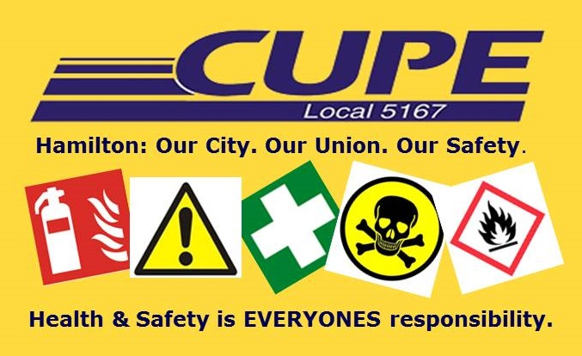

DEPARTMENT/DIVISION

WORKER REPRESENTATIVE(S)

